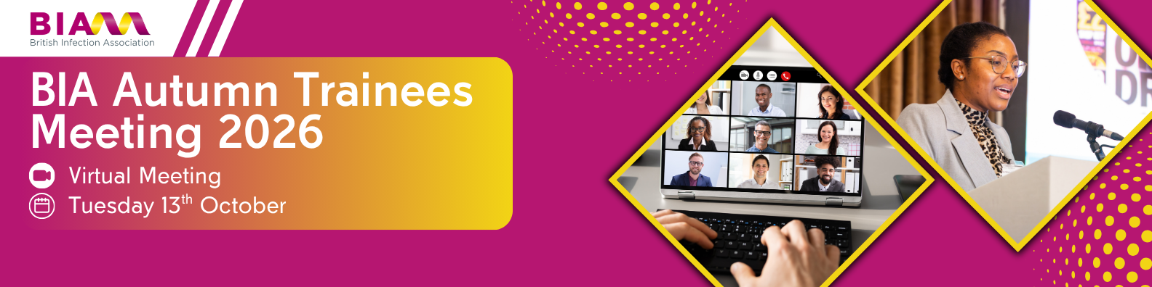
We would like to thank you for your interest in supporting this event.

SECTION 1: Sponsorship Package

I would like to proceed with the following partnership opportunity:
Sole Platinum Sponsorship

Cost: £3,250 +VAT
SECTION 2: Contact details of person to receive all further exhibition information

Company name:
First name: |  |  |  | Last name:
Job title: |  |  |  |  |  | Phone no.:
Email:

Section 3: Payment

Invoice address:
City & Postcode |  |  |  |  | Email (if  different from above)
Payment details:

INVOICE
A copy of your Purchase Order (PO) paperwork must accompany this booking form in order for it to be processed.
BACS payment to British Infection Association: Account No. 00272057 Sort code: 83-28-46
Expected payment date: _____________________________
Please email remittance advice to BIAFinance@fitwise.co.uk

SECTION 4: Terms and conditions of booking

By returning this booking form, you are accepting the terms and conditions stated below. If you have any questions about this please talk to us before returning the form.

Payment
Payment must be made in full within 30 days or prior to the event, whichever is sooner. Failure to pay will result in your company being refused participation in the event and you will still be liable for the full cost of your sponsorship and any ensuing costs. Invoices not paid within 30 day net will incur an 8.5% charge.

Cancellations
Refunds for sponsorship, which are cancelled, will only be made in the event of the sponsorship being sold out. Every effort will be made to re-sell all sponsorship space.

Company Information Submission Form
On receipt of your completed booking form you will be sent a link to submit your company information.
Deadline: 3 weeks prior to the live date of the event. You are encouraged to submit your information as early as possible to avoid possible issues. We cannot accept information after the deadline and amendments cannot be made after submission.
We kindly ask you to note that there is significant work that goes on behind the scenes to ensure submissions are uploaded accurately and in line with your booking. It is for this reason that we cannot extend deadlines or amend information that has been submitted. We thank you for your understanding.

ABPI and MedTech
It is the ‘Exhibitor / Sponsor’s’ responsibility to ensure that they are compliant.

Delegates – On registering all our delegates must confirm job titles and place of work. They will then receive login details and password ensuring that no members of the public can access the Conference.
We cannot guarantee that all delegates will be from the UK only however the ‘Exhibitor / Sponsor’ may include a disclaimer on their listing if required.

Delegate contact – The ‘Sponsor’ will receive a full delegate list post conference to include name, job title, organisation, location and email address however it will be the ‘Sponsor’s’ responsibility to obtain unambiguous and positive consent from delegates to use this data for direct marketing purposes

Data Consent
Other third parties that will have access to your personal data.
Your data may be shared with the following organisations and third parties:
• Organising committee of the Event (Only name, job title, organisation and town/city will be given)
• For e-conferences, a third party e-conference provider if relevant “Talking Slides” (Only name, job title, organisation and email address will be given)

Prescribing/Adverse Data Information – This can be included as text in the ‘Sponsor’ listing or provided as a link when submitting their company information.

Comment function – this will be included on all Sponsor listing as standard and will only be removed on special request

Note on proofing
A static screen shot will be provided to you 1 week before the event. This is for information purposes only and will follow the standard layout as specified in the event booking form. If the information submitted is accurate, there should be no errors. Upon receiving login details to the e-conference (timescales will be event dependent), we would advise that you immediately check your ‘sponsorship’. On the rare occasion that a link (or similar) does not work, this can be rectified quickly by alerting the event team at events@fitwise.co.uk.

Bankruptcy or liquidation
In the event of a sponsor becoming bankrupt or entering into liquidation (other than voluntary liquidation for the purpose of amalgamation or reconstruction) or having the receiver appointed, the contract with
such a sponsor will terminate forthwith, the allotment of sponsorship will be cancelled and all sums paid by the sponsor under contract shall be forfeit.

Insurance
Sponsors are reminded of the need to consult their insurance company or insurance broker to cover themselves fully against all risks of the sponsorship.

For official use |  | Stand allocated
Date processed |  | Date Conf letter sent
Date Invoice sent |  | Date Payment received

