  Issue 25: Spring 2026
   |  |  |  | 

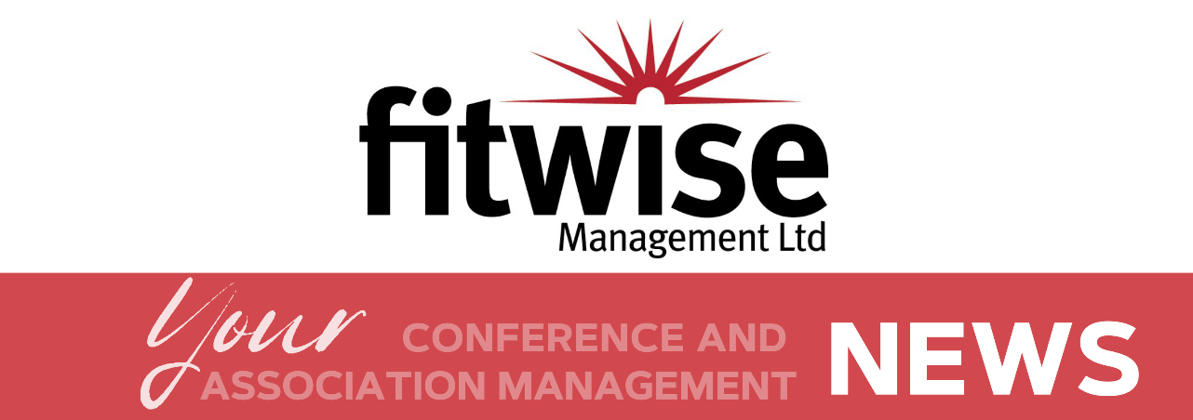

  Website
  Fitwise Website
  Client Resources

Welcome

  Welcome to your Spring 26 Newsletter
  We are delighted to welcome you, one of our key client contacts, to our regular quarterly newsletter, where we bring you highlights from our association management and conference world.
  We hope you enjoy this edition!
  

  
  Don't forget to access previous editions of the newsletter on the client resource page of our website.

Added Value

  ISO9001 Quality Management:
  We have quality processes at Fitwise
  and are pleased to report that in March
  we passed our ISO9001
  annual assessment.
  We are extremely proud to have
  retained this highly regulated standard
  for many consecutive years, which is
  testament to the quality of our internal
  processes and procedures. You can get
  on with your day job with assurance
  that you are in safe hands.
  View our quality policy here
  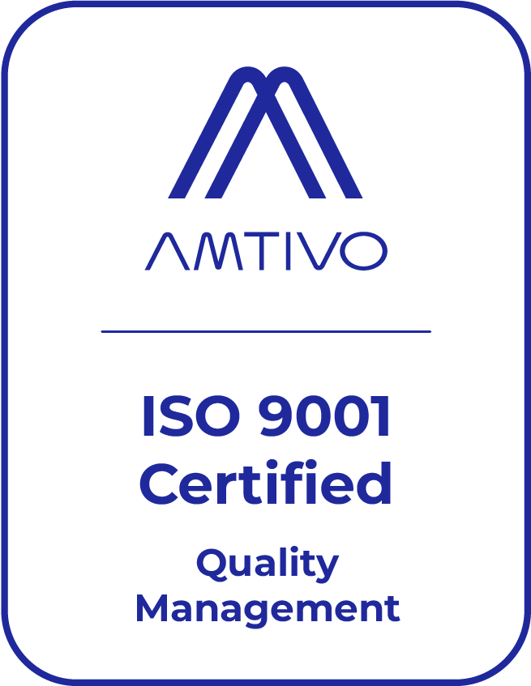

  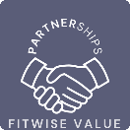
  

  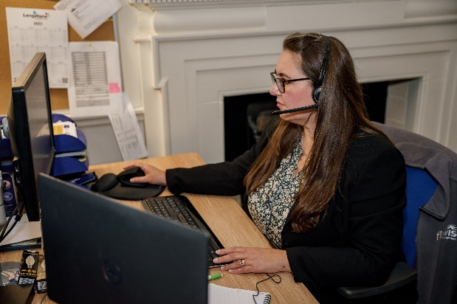
  New Phone System:
  Fitwise will soon be upgrading our phone system to improve call quality and make it easier for clients to reach us. We look forward to offering a smoother, more reliable experience once the update is complete.

  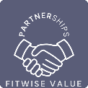
  



How to maximise your LinkedIn reach:

LinkedIn boosted posts are a cost-effective way to extend the reach of your existing content and get it in front of the audiences that matter most. With flexible budgets and precise targeting, they’re a simple way to boost visibility and engagement without running a full campaign. And if you need support, the Fitwise marketing team have the experience to guide you through the process and help you make the most of your spend.

Here is a useful guide and if you need any support from Fitwise please contact us.

  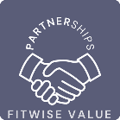
  

Updates

  PCO Services
  We’ve updated our Professional Conference Organisation document with the latest information, and we’d love for you to take a look. If there are any services you’re not currently using that could help you, just let us know - we’re always here to support you.
  And if you know anyone who might benefit from what we offer, we’d really appreciate a recommendation!
  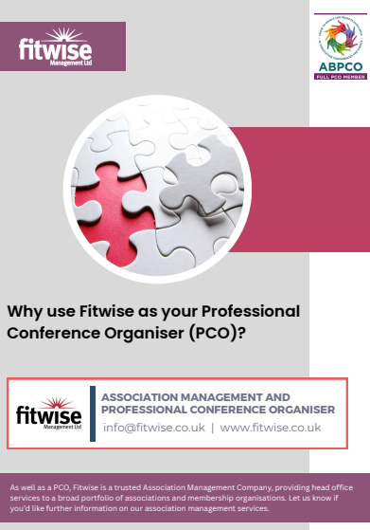

  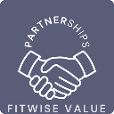
  
  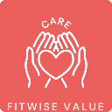

Next Edition
Fitwise Newsletter Issue 26 due: Summer 2026
Go behind the scenes and find out what keeps our talented team so busy
Make sure you check out our blog

Latest posts:
- Big enough to deliver, small enough to care!
- Maximising Your Event Marketing Budget
- Behind the Scenes of a Successful Conference
- Post Event Survey Guidance
- Healthcare Events and Where to Find Out About Them
- A Practical Guide to Joining Bluesky

If you would like to know more about how blogging could work for your association website please get in touch with our marketing team.

